GitLab Flow

What is GitLab Flow?
# Source: AI Source: Provided by: [Data Path: Persons Table -> ID Column: 1, Name_En Column: Motasem Essam] -> From: [ChatGPT] on [2/15/2026]
GitLab Flow is a flexible workflow that combines ideas from feature-based branching and environment-based release management.
It is designed to support continuous integration, continuous delivery, and multiple deployment environments (like staging, production, etc.) in a simple, structured way.
This workflow is widely used in teams that need both feature isolation and environment-based deployment control.

How It Works
# Source: AI Source: Provided by: [Data Path: Persons Table -> ID Column: 1, Name_En Column: Motasem Essam] -> From: [ChatGPT] on [2/15/2026]
- The main branch always contains stable, production-ready code.
- Developers create feature branches for tasks, bug fixes, or new functionality.
- Completed features are merged into the main branch after code review and testing.
- Environment branches (like staging or production) may exist to control deployments.
- CI/CD pipelines automatically test and deploy changes based on branch rules.

Conceptual Visualization
# Source: AI Source: Provided by: [Data Path: Persons Table -> ID Column: 1, Name_En Column: Motasem Essam] -> From: [ChatGPT] on [2/15/2026]
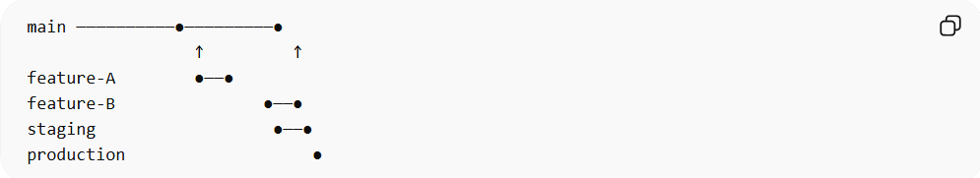
main ──────────●─────────●
↑ ↑
feature-A ●──●
feature-B ●──●
staging ●──●
production ●
- Feature branches isolate work.
- Main branch is stable.
- Environment branches control deployment stages.

When It Is Used
# Source: AI Source: Provided by: [Data Path: Persons Table -> ID Column: 1, Name_En Column: Motasem Essam] -> From: [ChatGPT] on [2/15/2026]
- Teams practicing CI/CD pipelines
- Projects with multiple deployment environments
- Agile and DevOps-driven teams
- Applications requiring frequent, controlled releases

Advantages
# Source: AI Source: Provided by: [Data Path: Persons Table -> ID Column: 1, Name_En Column: Motasem Essam] -> From: [ChatGPT] on [2/15/2026]
- Combines feature isolation with deployment control
- Supports CI/CD automation
- Flexible for different team sizes and project types
- Reduces risk in production releases

Disadvantages
# Source: AI Source: Provided by: [Data Path: Persons Table -> ID Column: 1, Name_En Column: Motasem Essam] -> From: [ChatGPT] on [2/15/2026]
- Slightly more complex than Feature Branch or GitHub Flow
- Requires proper branch naming and rules for environments
- Teams need discipline to maintain workflow structure

Key Idea (General Summary)
# Source: AI Source: Provided by: [Data Path: Persons Table -> ID Column: 1, Name_En Column: Motasem Essam] -> From: [ChatGPT] on [2/15/2026]
GitLab Flow = Feature branches + Main branch + Environment branches → CI/CD + controlled deployments
It is a flexible, environment-aware workflow suitable for modern software teams that need both feature isolation and safe, automated releases.

